**Khushi chauhan**

**Sap id –500105956**

**Rollno R2142220261**

**Experiment 4**

Lab Exercise 4- Working with Docker Networking

Step 1: Understanding Docker Default Networks

Docker provides three default networks:

· bridge: The default network when a container starts.

· host: Bypasses Docker’s network isolation and attaches the container directly to the host network.

· none: No networking is available for the container.

1.1. Inspect Default Networks

Check Docker's default networks using:

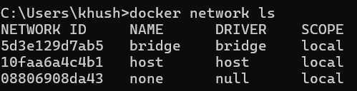

1.2. Inspect the Bridge Network

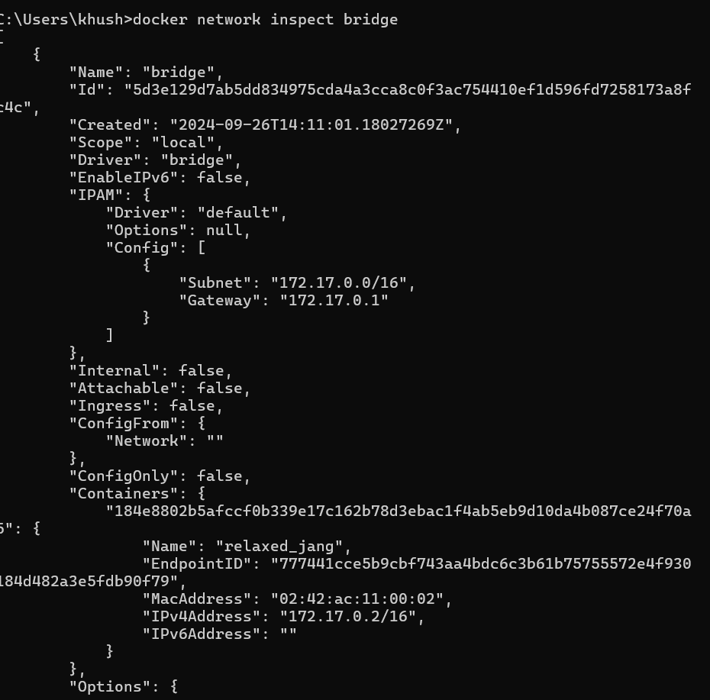

This command will show detailed information about the bridge network, including the connected containers and IP address ranges.

Step 2: Create and Use a Bridge Network

2.1. Create a User-Defined Bridge Network

A user-defined bridge network allows containers to communicate by name instead of IP.

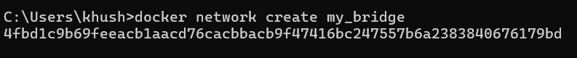

2.2. Run Containers on the User-Defined Network

Start two containers on the newly created my_bridge network:

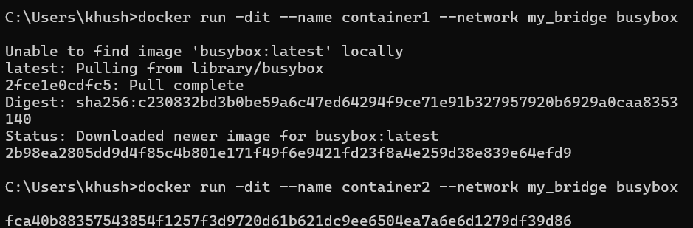

2.3. Test Container Communication

Execute a ping command from container1 to container2 using container names:

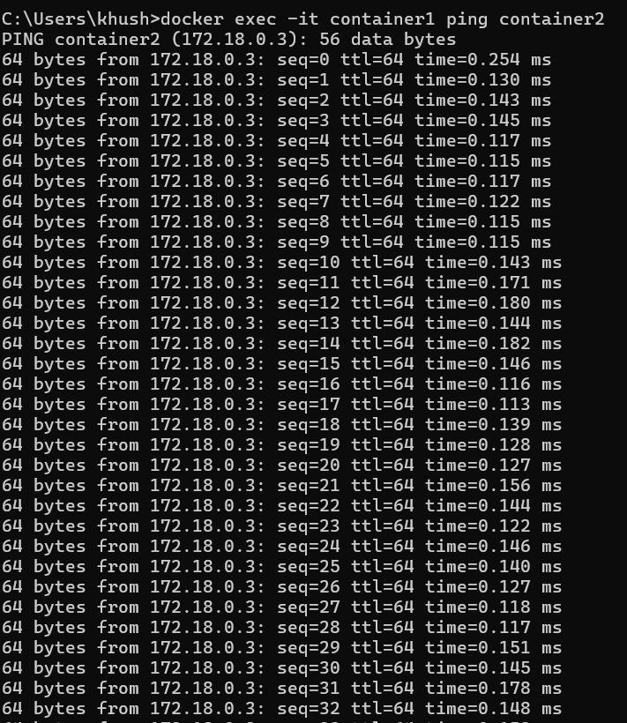

The containers should be able to communicate since they are on the same network.

Step 3: Disconnect and Remove Networks

3.1. Disconnect Containers from Networks

To disconnect container1 from my_bridge:

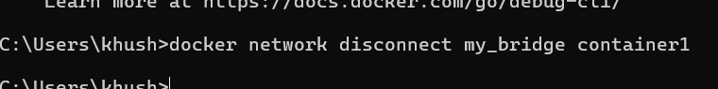

4.2. Remove Networks

To remove the user-defined network:

Step 4: Clean Up

Stop and remove all containers created during this exercise:

